THE THEORY OF DEBRANDING
Through the span of the most recent years, you may have seen organizations over all businesses streamlining their marking. All things considered, there's significantly more to this change than simply the world's fixation on the level plan. The eventual fate of marking resembles a radical, broad debranding development.
Debranding happens when an organization expels its name from its logo for an advertising effort trying to influence themselves to seem not so much corporate but rather more individual.Why will a company do so? Weren’t they aways been trying to build their brand.Well with the world generation changing, today consumers know a ploy when they see one. What's more, they're totally tired of them. As quoted by Fast Company, “the brand that screams the loudest no longer commands the most attention.” But now it’s the brand that gives something useful does.
The very intent of developing a brand is to make the consumers believe that they are consuming a familiar and reliable product. While trying to trap shoppers into opening their wallets,Hiding your genuine nature is never a smart thought. Another issue is simply the rationale behind marked substance. It's deceptive to utilize an entirely unexpected arrangement of qualities– great stories– to offer an item that has characteristically nothing to do with these qualities.Take Thumps up as an example, is it really has something to do with our fear? No. Its just a soft drink. People are becoming more aware that “Daar kea aage jeet hai” but Thumps up is not taking you there.
Shoppers are more suspicious of brands than ever; and realness, regardless of its genuine claims, is sufficient to slice through the commotion and create an impression.

The market is moving towards a future where the products will speak for themselves rather than their brands. The message from the brand will be less significant than that conveyed about the product by its quality and utility.
In our debranded future, shoppers won't really spend less– yet they will purchase less. They will purchase less disposable clones and spend more on just a couple of value fundamentals against a reasonable exchange cost. The move among brands from putting resources into marketing to resources into product improvement should likewise enable less blessed individuals to purchase unadulterated, basic, quality items. Costs will reflect genuine esteem, not the calculated esteem marking presented by brands. Items will be stripped of marking codes and developed conjured up universes. The main data on bundling will be highlighted, for example, starting point, the aims of the producer, the generation procedure, and the natural effect. Perhaps creators will figure out how to quietly mark their item by adding their mark to the item itself, precluding bundling by and large. The greater part of this will obviously be a sort of marking also, yet stripped to its center.
Rather than tossing cash at yet another marked substance crusade, backpedal to the first idea of a brand. Adjust your item's quality, outline, and its sturdiness. Turn into a maker of shoes again rather than being a surrogate of deep sense. It will make your life, and purchasers' lives, less complex. Try not to toss another item available if it's not characteristically preferable and tougher over what as of now exists. We needn't bother all the more marking; we require less, better-quality items. Individuals will discover us.
When coca cola introduced these cans with no name, many were actually confused. They printed the popular names of people in Britain and launched their campaign. It was very successful as people could see their names in the product and also loved to share the same with their friends having their name written in it. Although the product did not have its name written on the label, the sleek design along with the red and white script makes it recognisable instantly. Had this been tried by some non-popular brand, it might not have worked too well.
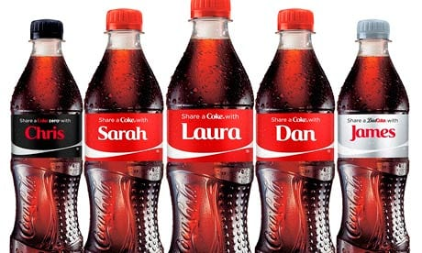
Fig 1: Customised Coke bottles¹
Starbucks also tried to implement the theory of unbranding by debranding some of its stores that looked more local and people thought it to be more approachable.
Debranding can go wrong as well if not planned properly. Sony Pictures discharged a debranded DVD of its film The Girl with the Dragon Tattoo, trying to tie the item in with its 'programmer' subject. Yet, the plate, which looked 'hand crafted', did not coordinate the 'smooth promoting and photographic plan' whichever remainings of the stock highlighted, as analysed by Marketing Week calls attention to. Indeed various purchasers trusted it was phony and attempted to return it.
References:
1.https://www.theguardian.com/media-network/media-network-blog/2013/aug/06/coke-debranding-name-dropping
2.https://www.fastcodesign.com/3060658/the-future-of-branding-is-debranding

